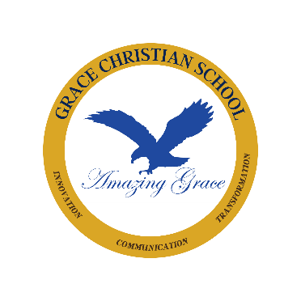
Dental Examination Form
10760 Thornmint Rd, San Diego, CA 92127
admission@gracechristianschool.org
(858) - 568 - 8696

GRACE CHRISTIAN SCHOOL is dedicated to the spiritual, intellectual, and personal development of all students. We have created a nurturing environment where our students can discover their entire person. Grace Christian School welcomes your children to join our family and begin their successful future.
Accredited by The Accrediting Commission for Supplementary Education, Western Association of Schools and Colleges.

Please complete this DENTAL EXAMINATION form for your application to GRACE CHRISTIAN SCHOOL, it must be completed and signed by a DENTAL EXAMINER.

